

Minesweeper Game
The Classic Puzzle That Keeps Us Clicking
A timeless logic puzzle that has captivated millions since its debut on Windows 3.1. Simple rules, infinite strategy, and the thrill of avoiding hidden mines.
What is Minesweeper?
Minesweeper is a single-player logic puzzle game where you clear a minefield without detonating any hidden mines. The board displays a grid of hidden squares—some contain mines, others reveal numbers indicating how many adjacent mines surround them.
First popularised as a Windows staple, it remains available across multiple platforms worldwide, from desktop computers to mobile devices. The elegant simplicity belies its strategic depth.
How to Play: The Rules Simplified
Click to Reveal
Select any hidden square to reveal what's beneath.
Mine or Safe?
Hit a mine and it's game over. Otherwise, you're safe to continue.
Read the Numbers
Numbers show how many mines exist in the 8 adjacent squares (up to 8 neighbors total).
Empty Cascade
Zero adjacent mines triggers automatic reveal of surrounding safe squares.
Flag Wisely
Mark suspected mines with flags to prevent accidental clicks and track your progress.
The Classic Experience: Nostalgia and Strategy
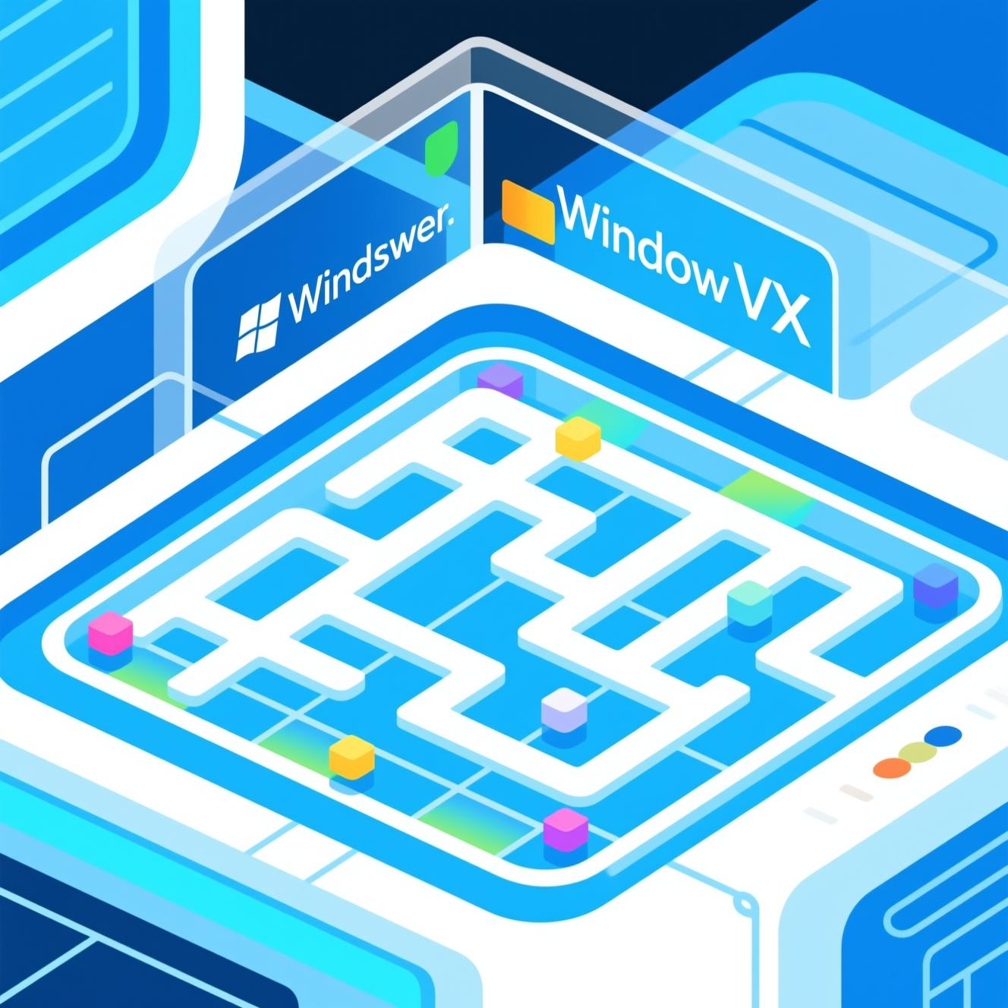
Minesweeper first appeared on Windows 3.1 and became iconic on Windows XP, captivating millions during the formative years of personal computing. It combines logical deduction, pattern recognition, and occasional luck to create an addictively challenging experience.
Standard Difficulty Levels
- Beginner: 9×9 grid, 10 mines
- Intermediate: 16×16 grid, 40 mines
- Advanced: 24×24 grid, 99 mines
Behind the Scenes: How Minesweeper Works
Grid Data Structure
Each cell tracks whether it contains a mine, has been revealed, or is flagged by the player.
Adjacent Mine Calculation
Numbers are calculated by scanning the 8 surrounding cells for mines and displaying the count.
Flood Fill Algorithm
Revealing empty cells triggers recursive expansion to uncover all connected safe areas automatically.
Smart Mine Placement
Mines are randomly distributed but strategically excluded from the first clicked cell, guaranteeing an opening.
Coding Minesweeper: A Developer's Perspective
Programming Languages
Built using C, C++, JavaScript, Python, or modern frameworks like React with TypeScript for cross-platform compatibility.
Core Challenges
Efficient empty cell reveal algorithms, responsive user input handling, and optimised UI rendering across devices.
Advanced Implementations
Recursive matrix-based logic solves boards, generates puzzles, and replicates the retro Windows-style interface using libraries like React95.
Minesweeper Variants and AI Insights
Modern Enhancements
Newer versions include explainable hints and AI-generated solvable boards. These features reduce frustration by ensuring puzzles can be solved through pure logical deduction rather than pure guesswork.
Some advanced puzzles still present 50/50 mine placement scenarios, challenging even expert players and adding an element of unpredictability.

Minesweeper in Data Analytics and Visualization
Creative adaptations leverage tools like Power BI to recreate Minesweeper logic using slicers, bookmarks, and calculated measures. This demonstrates how game logic can be modelled within data analytics platforms and visualisation frameworks.
These innovative applications show the versatility of Minesweeper beyond traditional gaming into educational, analytical, and professional domains, proving that classic game mechanics inspire solutions across diverse fields.
Minesweeper's Enduring Appeal
Simple Rules
Easy to learn, yet strategically deep
Strategic Thinking
Logical deduction and pattern recognition
Global Community
Online leaderboards and shared strategies
Gaming History
Iconic symbol of early computing
Minesweeper combines accessibility with depth, continuing to inspire developers, gamers, and puzzle enthusiasts globally. Communities on minesweepergame.com and GitHub preserve strategies, records, and the rich history of this timeless game.
Ready to Play and Code Your Own?
Try Classic Minesweeper
Play online versions or revisit the Windows original to refresh your skills.
Explore Open Source
Discover community-built projects on GitHub showcasing diverse implementations and creative variations.
Build Your Version
Experiment with React hooks, C programming, or your language of choice to create your own Minesweeper experience.
Join the Journey
Every click is a step into logic, luck, and timeless fun. The game awaits your strategic brilliance.

